**CONTENTS**

**ABSTRACT………………………………………………………………………………….iii**

1. **INTRODUCTION…………………………………………………………………………1**
2. **PROPOSED APPROACH………………………………………………………………..2**
   1. Components of System Architecture………………………………......…………………..2

2 .1.1 Arduino Pro Mini …………………………………………………….….……………..2

* + 1. LPG Gas sensor Module………………………….………………………….………..3
    2. Buzzer……....…………………………………………………………………………4
    3. Transistor……………..………………………..………………………………………..4
    4. Bread Board……………………………………………………………..………….…5
    5. Connecting wires………………… ………….………………………………………..5

1. **Time Scheduling ……………………………………………………………………...6**
2. **Block Diagram of the User Interactive Gas Leakage and Fire Alarm System……………………………………………………………………….7**
3. **Implementation Requirements…………………………………………….8**
4. **System analysis and Design………………………………………………..9**
5. **Backend Design…………………………………………………………….10**
6. **RESULTS AND DISCUSSIONS………………………………………….11**
7. **Conclusion and Future Work……………………………………………..12**

9.1. Conclusion………………………………………………………………12

9.2. Future Work……………………………………………………………...12

**Abstract**

A gas leakage system has been built with the use of embedded systems and the Internet of things (IoT), keeping in mind the life-threatening instances of blasts and injuries caused by gas leaks in industries, automobiles, and homes, for the goal of protecting lives and fulfilling social obligations. Designing a dangerous gas detecting and alerting system using microcontrollers is the major goal of the effort. LPG is a major and efficient fuel that is typically used for cooking in private spaces. Most of the time, LPG was filled in the solid, difficult-to-damage cylinder. Anyhow, if a gas cylinder, controller, or gas pipe tube is in poor condition and likely to result in an accident, breaks could occur. Mistakes could lead to physiological issues like asphyxia and could have an effect on how a fire or an electric supply starts. Installing a gas leakage detector in hazardous locations is one of the crucial preventive measures to stop accidents caused by gas spills. This paper's main goal is to give an outline that can be used to identify and clean up gas spills in vulnerable locations. The gas spill sensor is a device that may identify gas spills in their initial stages and warn people about them. This paper primarily controls the development of a simple gas spill locator at the initial stage and later transforms this uncomplicated device into a most innovative gas identification framework. We basically use MQ-6 Sensor Module which is a generic gas sensor used to detect LPG presence. The Module has Digital Out and Analog Out. It Detects LPG from 200ppm to 10000ppm.

**Keywords:** Liquid petroleum gas, Gas sensor, Leakage

1. **INTRODUCTION**

The modern era is a technological era. Humans rely on embedded systems more and more. This dependence is growing tremendously in recent days. Gas leaking causes a number of mishaps that cause property damage and human injuries. The risk of explosion, firing, and suffocation are based on their physical properties such as toxicity, flammability, etc. In recent years, there have been more fatalities related to gas cylinder explosions. The reason for such explosion is due to substandard cylinders, old valves, worn-out regulators, and a lack of awareness in handling gas cylinders. A flammable mixture of hydrocarbon gases known as LPG or propane is used as fuel in a variety of applications, including homes, hostels, businesses, cars, and other vehicles due to its advantageous characteristics, which include a high calorific value, little smoke, and soot production, and minimal environmental harm. Another fuel that is commonly utilized in homes is natural gas. Both gases burn to produce clean energy, however, there is a serious problem with their leakage. Being heavier than air, these gases do not disperse easily. It may lead to suffocation when inhaled and may lead to an explosion. This paper presents an LPG leakage detection and alert system to avoid fire accidents and to provide house safety.

**2. PROPOSED APPROACH**

2.1 Components of System Architecture

1. Arduino Pro Mini
2. LPG Gas sensor Module
3. Buzzer
4. BC 547 Transistor
5. 16x2 LCD
6. 1K resistor
7. Breadboard
8. 9 volts battery
9. Connecting wires

**2.1.1. ARDUINO UNO:**

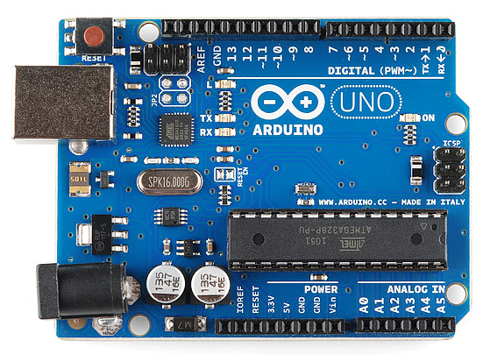

The Arduino Uno is one kind of microcontroller board based on ATmega328, and Uno is an Italian term that means one. The Arduino Uno Board 1.0 microcontroller board will soon be released, hence the name Arduino Uno. This board has 14 digital I/O pins, an ICSP header, a power jack, 6 analogs I/Ps, a ceramic resonator operating at A16 MHz, a USB port, and 14 digital I/O pins. By connecting this board to the computer, all of these can help the microcontroller's future operations. This board's power source can be accomplished via a battery, a USB cable, or an AC to DC adaptor.

**2.1.2. LPG Gas Sensor Module:**

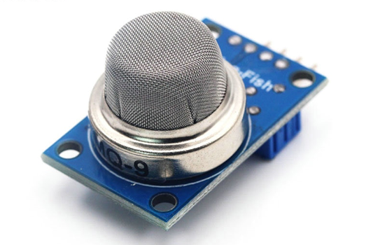

The SEN-1327 LPG Gas Sensor Module is designed to enable an LPG detection interface to the Microcontroller without ADC Channels. It allows determining when a preset LPG gas level has been reached or exceeded. Interfacing with the sensor module is done through a 4-pin SIP header and requires One I/O pin from the host microcontroller.

The onboard microcontroller provides an initial heating interval after powerup and then starts to ensure LPG sensor output. If it found the LPG contents above the set value, it will inform the Host controller by pulling the Output Pin to High and Starting to blink an onboard status LED. The sensor module is mainly intended to provide a means of comparing LPG sources and being able to set an alarm limit when the source becomes excessive.

**2.1.3. Buzzer:**

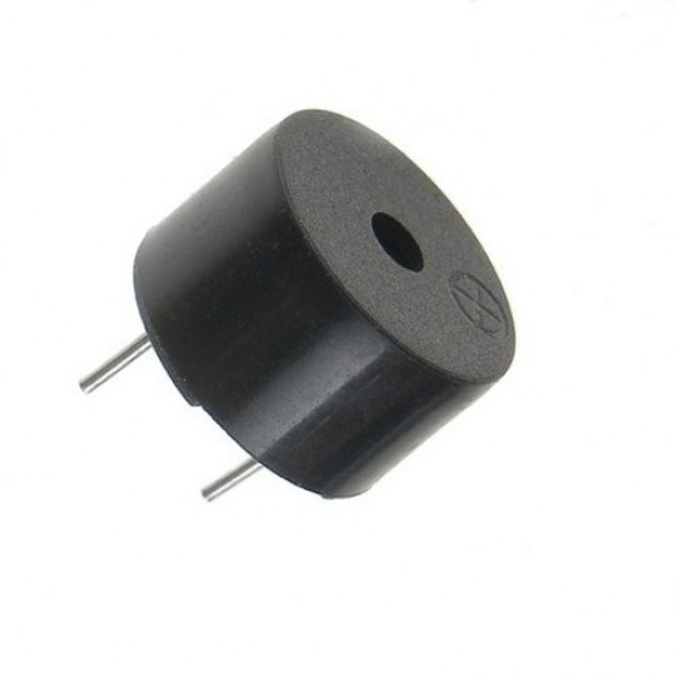

Buzzers are used for the alarm. It works like an alarm by making a sound. It has two pins, one of them is positive and the other is negative. By implementing the buzzer pins we produce a sound alarm. In our project this buzzer will be used to identify the gas, if leakage happens then the buzzer will turn on by making a sound.

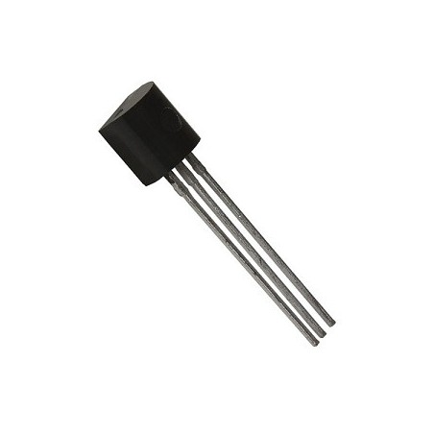**2.1.4. BC 547 Transistor:**

The BC547 transistor is an NPN transistor. A small current of the base terminal of this transistor will control the large current of the emitter and base terminals. The main function of this transistor is to amplify as well as switch purposes. The maximum gain current of this transistor is 800A.

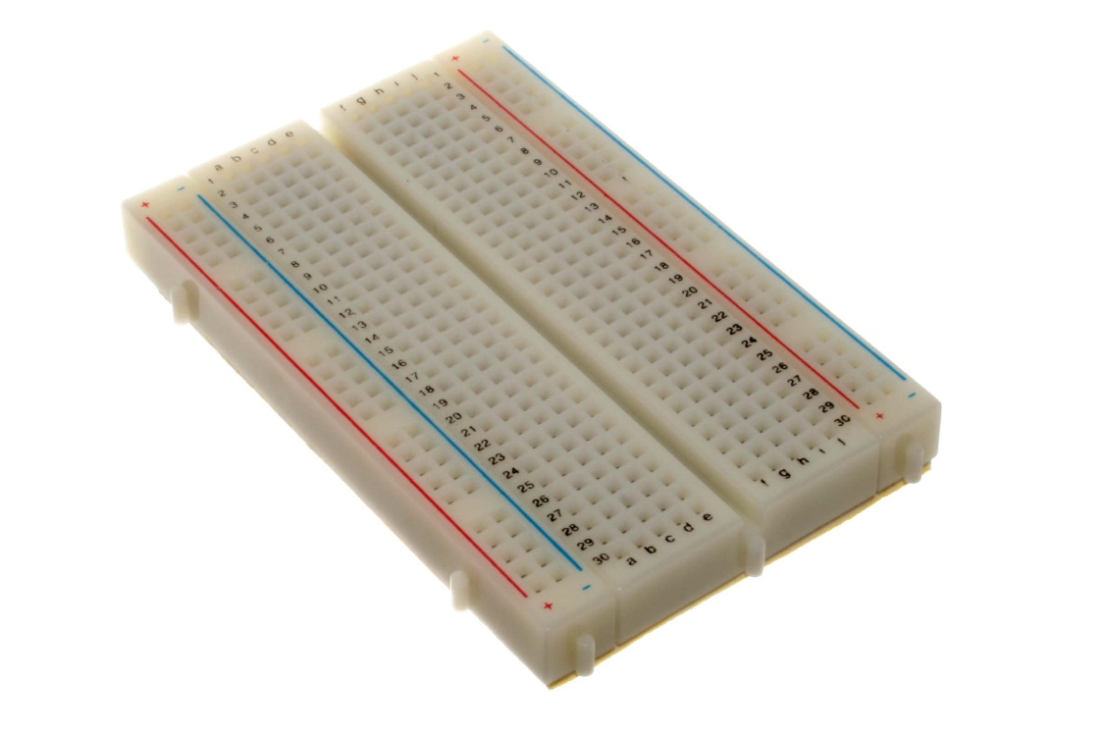**2.1.5. Bread Board:**

A Breadboard is simply a board for prototyping or building circuits on. It allows you to place components and connections on the board to make circuits without soldering. The holes in the breadboard take care of your connections by physically holding onto parts or wires where you put them and electrically connecting them inside the board. The ease of use and speed are great for learning and quick prototyping simple circuits. More complex circuits and high-frequency circuits are less suited to breadboarding. Breadboard circuits are also not ideal for long-term use like circuits built on perf board (protoboard) or PCB (printed circuit board), but they also don’t have the soldering (protoboard), or design and manufacturing costs (PCBs).

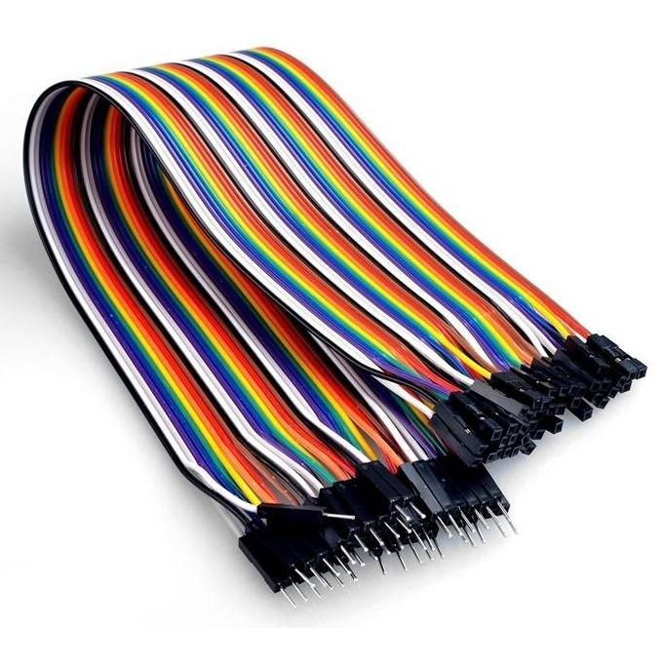**2.1.6. Connecting wires:**

A wire may be a single, typically cylindrical, versatile strand or rod of metal. Wires square measure accustomed bear mechanical masses or electricity and telecommunications signals. The wire is often fashioned by drawing the metal through a hole in a very die or draw plate. Wire gauges are available in numerous customary sizes, as expressed in terms of a gauge range. The term wire is additionally used additional loosely to confer with a bundle of such strands, as in "multi-stranded wire", which is additionally properly termed a wire rope in mechanics, or a cable in electricity. Connecting wires will be made up of Al and different materials the majority of electrical wires square measure fabricated from copper.

**3.** **Time Scheduling**

|  |  |
| --- | --- |
| Planning | 2 weeks |
| Design & Analysis | 5 weeks |
| Coding | 2 weeks |
| Testing & Implementation | 3 weeks |
| Total | 12 weeks |

**4.** **Block Diagram of the User Interactive Gas Leakage and Fire Alarm System.**

**GAS Sensor**

**Audio Alert Unit**

**Timer**

**Visual Alert Unit**

Figure 7: Block Diagram of the User Interactive Gas Leakage and Fire Alarm System.

**5.** **Implementation Requirements:**

All the Implementation requirements are given below.

Implementation Requirement.

|  |  |  |  |
| --- | --- | --- | --- |
| Arduino UNO | Hard Board | Register | Base Board |
| LED | Buzzer | A2B Cables | Jumper Wire |
| MQ-6 sensor Module | Pin |  |  |

**6.** **System analysis and Design:**

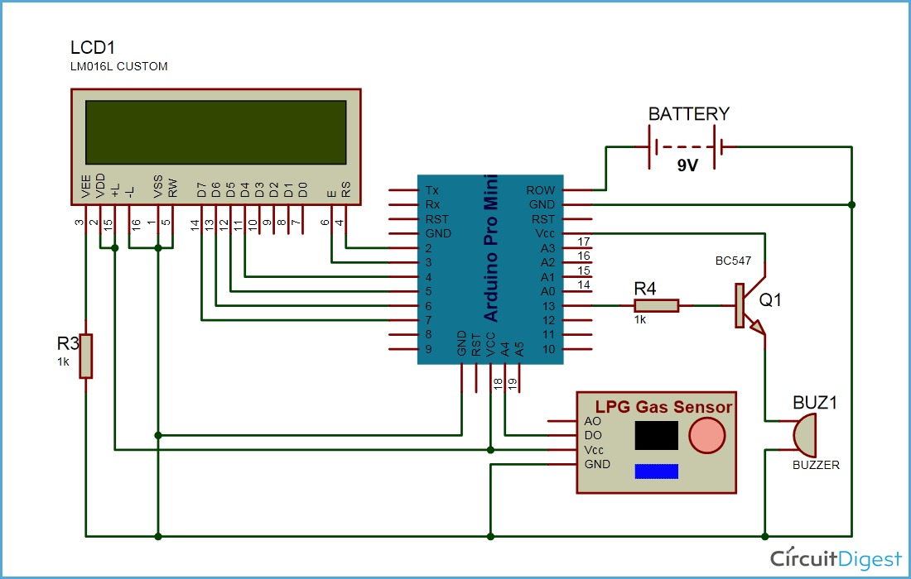

Although LPG is a necessity in every home, its overuse and carelessness can lead to a disaster. Here we have initially developed an Arduino companion to warn about LPG outpouring and to monitor the outpouring of large quantities of product to avoid any mishaps in this area. Based on the LPG gas detector, this device will send a warning signal to the user with the help of an alarm and LCD display. This method is easy to implement, and anyone with some knowledge of physics and programming can build it, and my main goal of this project is to make it easily accessible to the public.

Arduino board, LPG GAS device module, buzzer, and 16x2 liquid crystal display module are all shown in the above diagram that I am using in this project. I created this diagram using proteus software. Arduino controls the entire process of this technique, including reading the LPG gas device module output, sending a message to the liquid crystal display, and activating the buzzer. We can adjust the sensitivity of this device module using an internal potentiometer.

The circuit starts working after the device is supercharged. The microcontroller receives the analog voltage from the MQ-6 device and initiates a warning on the LCD digital display. MQ5 devices have four pins on the gas module. Two pins are used to interface with the breadboard and the other two pins are VCC and Ground. One of the two interfacing pins is an analog output pin and the other is a digital pin.

The analog output pin of this module is used for gas outpouring and concentration level detection. It is interfaced with the A0 analog input pin of the Arduino board. The analog voltage from the device is digitized using the built-in ADC channel and stored as a 10-bit value. The gas concentration value is displayed on the 16X2 show LCD digital display. It is connected to the Arduino board and its knowledge pins are connected to pins 4-7 of the Arduino board. I connected the RS and E pins of the Liquid Crystal Display Area Unit to the D2 and D3 pins of the Arduino UNO on multiple occasions. RW pin of liquid crystal display is connected below. The device value is compared to a labeling threshold, and if the device value exceeds that threshold, the buzzer is activated.

Connect the buzzer to the weight unit pin of the Arduino. A 10k potentiometer is also connected to the liquid crystal display pin, the battery, and thus to the ground. It can be used to distinguish between alphabets or numbers written on the show LCD digital display.

**7.** **Backend Design:**

|  |
| --- |
| #include<Servo.h>  #include <LiquidCrystal.h>  #include <SoftwareSerial.h>  Servo myservo;  int pos = 0;  int val;  LiquidCrystal lcd(12, 11, 5, 4, 3, 2);  SoftwareSerial mySerial(9, 10);  byte tx = 1;  const int Buzzer = 6;  const int DC_Motor = 7;  int gasC_1 = 0; //set initial tempC 0 for all MQ 3  int smkC_1 = 0; //set initial tempC 0 for all MQ 2  const int SensorPin1 = A0; //fire input sensor pin  const int SensorPin2 = A1;  void setup()  {  lcd.begin(16, 2);  delay(100);  pinMode(tx, OUTPUT);  myservo.attach(13);  pinMode(Buzzer, OUTPUT);  pinMode(SensorPin1, INPUT);  pinMode(SensorPin2, INPUT);  pinMode(Buzzer, OUTPUT);  pinMode(DC_Motor, OUTPUT);  mySerial.begin(9600);  Serial.begin(9600); //Start the serial connection with the computer  }  void loop()  {  int gasC_1 = analogRead(SensorPin1);  int SmkC_1 = analogRead(SensorPin2);  gasC_1 = analogRead(SensorPin1); //read the value from the LM35 sensor  gasC_1 = (5.0 * gasC_1 * 100.0) / 1024.0; //convert the analog data to temperature  smkC_1 = analogRead(SensorPin2); //read the value from the MQ 2 sensor  smkC_1 = (5.0 * smkC_1 * 100.0) / 1024.0; //convert the analog data to temperature  delay(50);  if (gasC_1 >= 100 || smkC_1 >= 100)  {  val = analogRead(pos);  val = map(val, 0, 1023, 0, 180);  myservo.write(val);  delay(50);  digitalWrite(DC_Motor, HIGH);  lcd.clear();  lcd.setCursor(0, 0);  lcd.print(" THERE IS FIRE ");  lcd.setCursor(0, 1);  lcd.print(" NOT SAFE HERE ");  delay(100);  digitalWrite(Buzzer, HIGH);  delay(200);  digitalWrite(Buzzer, LOW);  delay(200);  digitalWrite(Buzzer, HIGH);  delay(200);  digitalWrite(Buzzer, LOW);  delay(5);  }  else  {  digitalWrite(DC_Motor, LOW);  myservo.write(95);  lcd.clear();  lcd.setCursor(0, 0);  lcd.print(" NO FIRE ");  lcd.setCursor(0, 1);  lcd.print(" ALL SAFE ");  }  } |

**8.** **RESULTS AND DISCUSSIONS:**

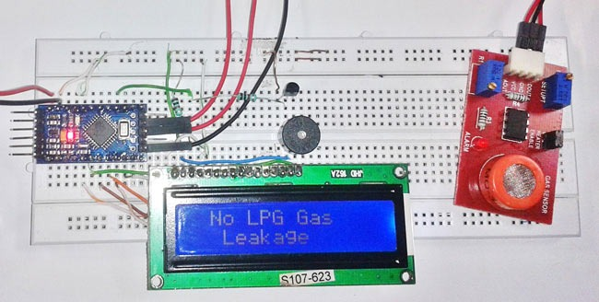

In today's world, security is very important, and smart security systems must be implemented in residential, non-residential, educational, and workspaces. LPG or gas, which is a flammable mixture of organic gases is used as fuel in numerous areas like homes, hostels, industries, and automobiles. Because of its attractive properties such as high heating value, low smoke generation, and less damage to the environment. LPG gas can explode if released into the air LPG gas explosions have increased the number of deaths in recent years. This device is used to avoid this problem and prevents LPG gas leakage which helps prevent gas wastage.

**9.** **Conclusion and Future Work:**

**9.1.** **Conclusion:**

Gas leaks can cause serious accidents, resulting in material damage and human injury. Gas escapes primarily occur as a result of poor equipment maintenance and inadequate personal awareness. Thus, LPG escape detection can help prevent accidents and save lives. This paper presented an LPG detection and warning system. When an LPG escape is detected, this technique activates a buzzer and displays the severity of the escape to alert individuals. This method is very straightforward. Still, reliable.

**9.2.** **Future Work:**

Scope for Further Developments We could have done some more work. We need to continue with some related future work,

1. Making it more reliable as it can work within a large space of range.
2. Making a fireproof cover for its internal part's safety.
3. We want to make a product base on this project.
4. Increasing the accuracy of device performance.